Check your database config in NetBeans by going to services, then right clicking your connection and clicking Properties. For your properties make sure the Database URL, driver, driver class, schema, and user all match these.

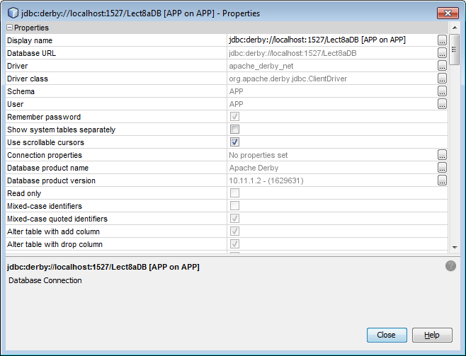

If that looks good check your Glassfish config. Open up the admin console then click on JDBC connection pools and verify that it matches this for the lect8apool

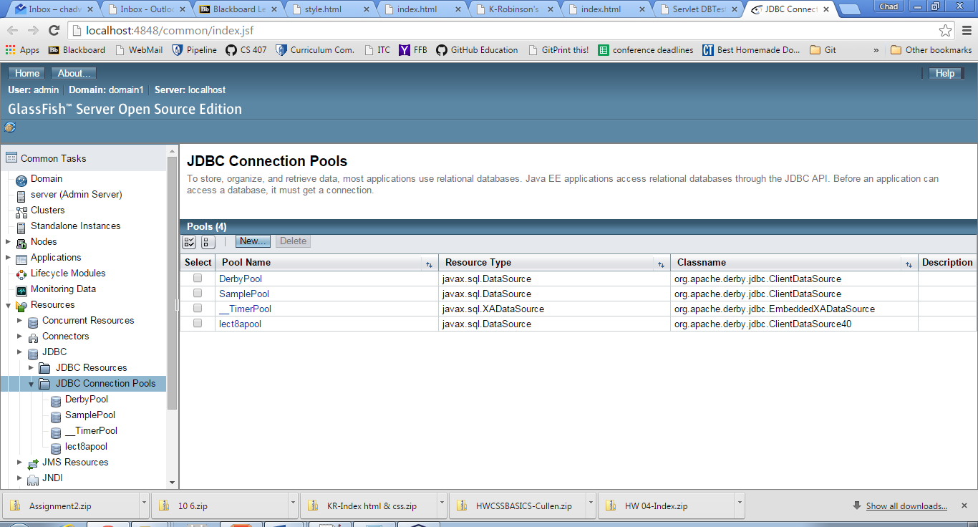

If that looks good check this next:

PoolName, ResourceType, Datasource Classname

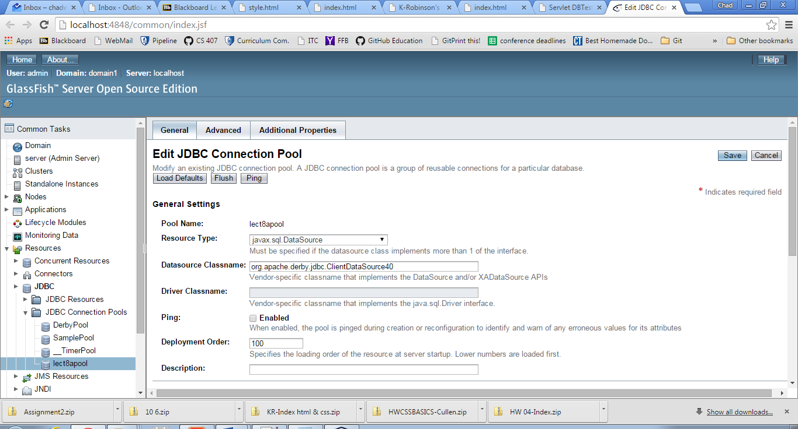

If still good check these under the additional properties. You should have exactly these **and no more.** If I were to guess it would be that the problem is likely somewhere in here.

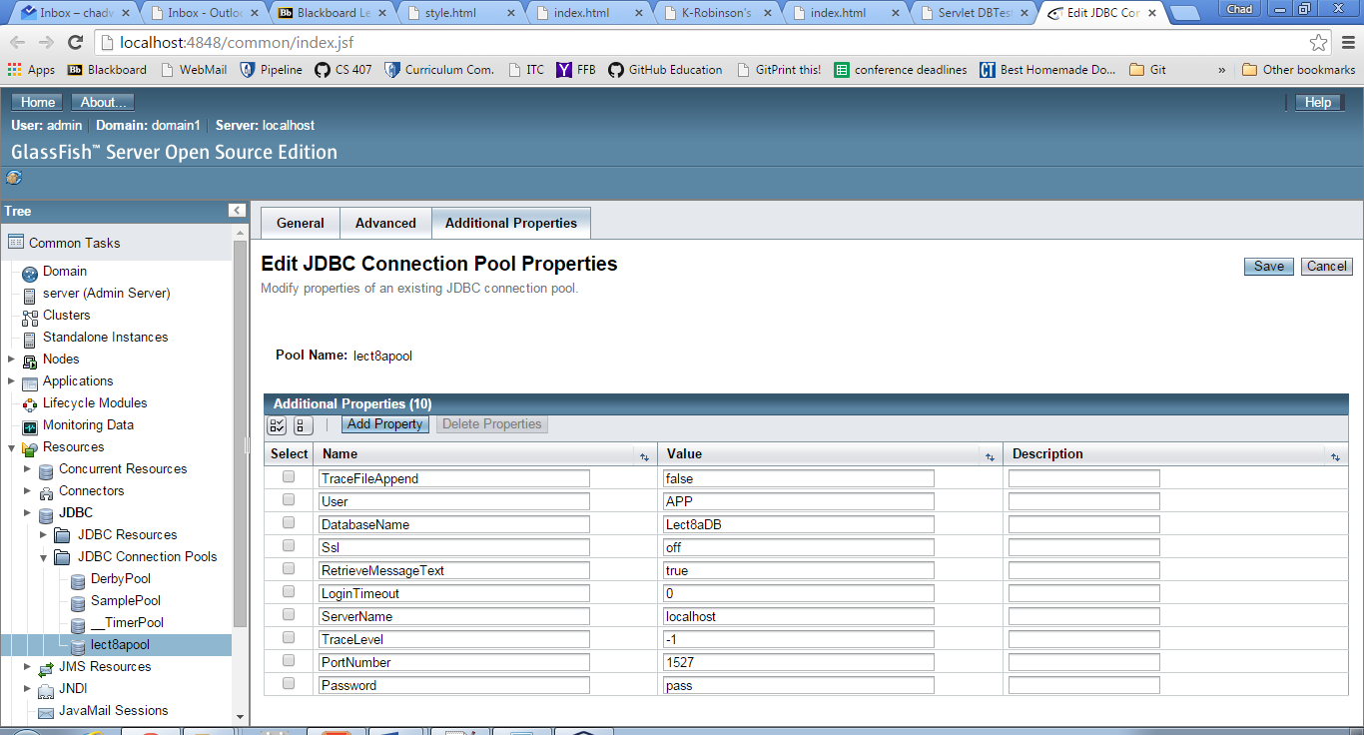

If still good check out your JDBC resource for your pool. It should look like this:

Specifically check the JNDI name and the pool name

